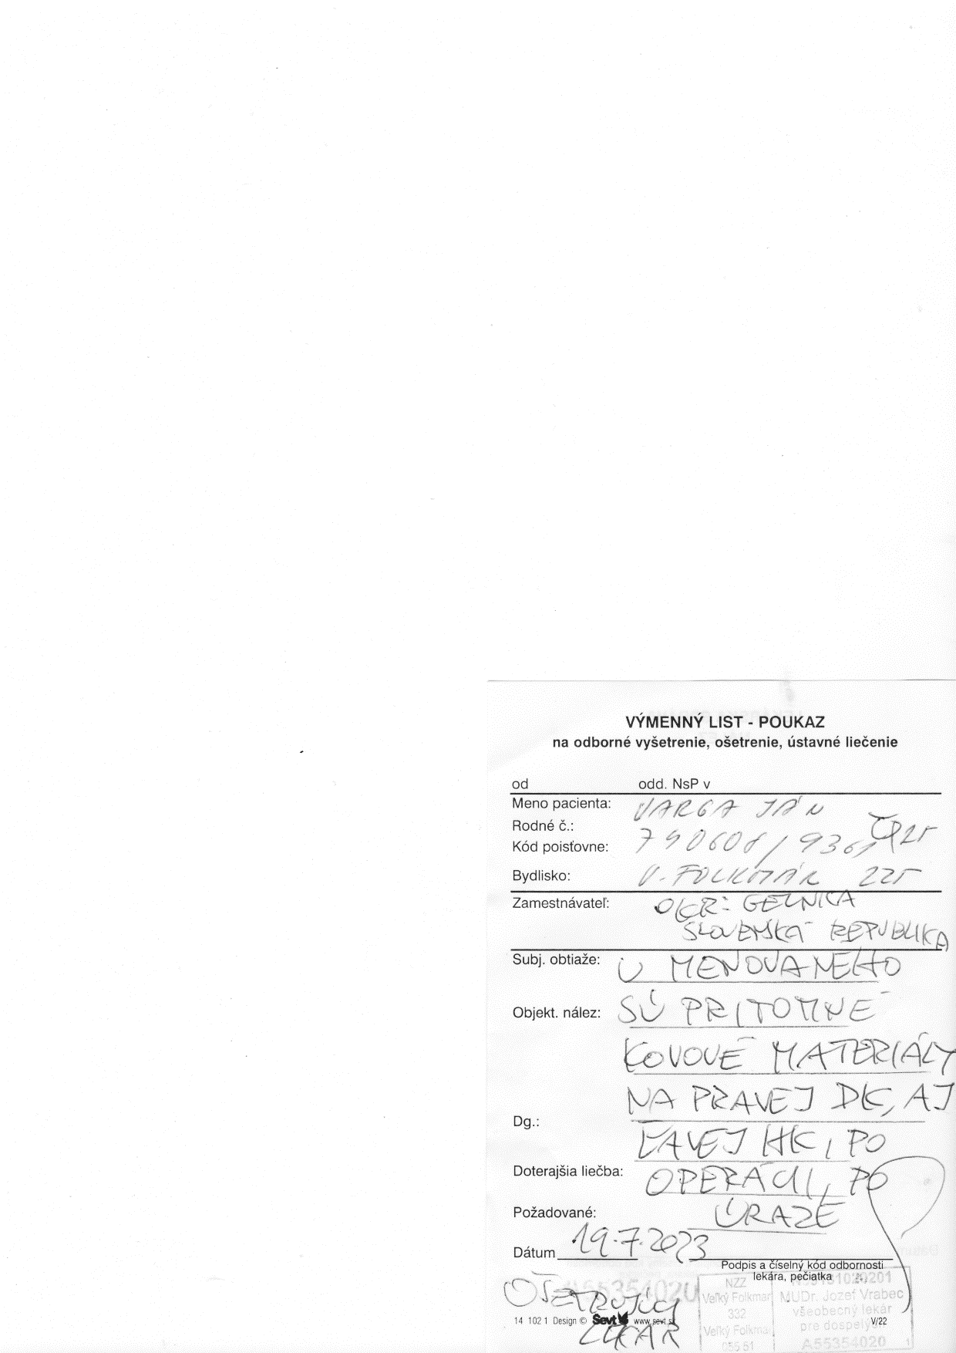Metallic materials are present on both the right lower limb and the left upper limb, post-surgery, post-trauma